**DAILY ONLINE ACTIVITIES SUMMARY**

|  |  |  |  |  |  |  |  |  |
| --- | --- | --- | --- | --- | --- | --- | --- | --- |
| **Date:** | 13-06-2020 | | | | | **Name:** | D Richard Franklin | |
| **Sem & Sec** | Fourth sem section A | | | | | **USN:** | 4AL18CS020 | |
| **Online Test Summary** | | | | | | | | |
| **Subject** | | Data communication | | | | | | |
| **Max. Marks** | | 30 | | **Score** | | | 29 | |
| **Certification Course Summary** | | | | | | | | |
| **Course** | 1. **Introduction to R** | | | | | | | |
| **Certificate Provider** | | | greatlearning | | **Duration** | | | 3 hr |
| **Coding Challenges** | | | | | | | | |
| **Problem Statement:**  1: Program to print prime numbers in an interval | | | | | | | | |
| **Status:** completed | | | | | | | | |
| **Uploaded the report in Github** | | | | | yes | | | |
| **If yes Repository name** | | | | | <https://github.com/alvas-education-foundation/Richard_Franklin> | | | |
| **Uploaded the report in slack** | | | | | yes | | | |

**Online Test Details:**

It was from modules 1 and 2 and the test was for 30 minutes having 30 questions, all multiple choice questions. The questions were simple and optimal and the score that I got was 29/30

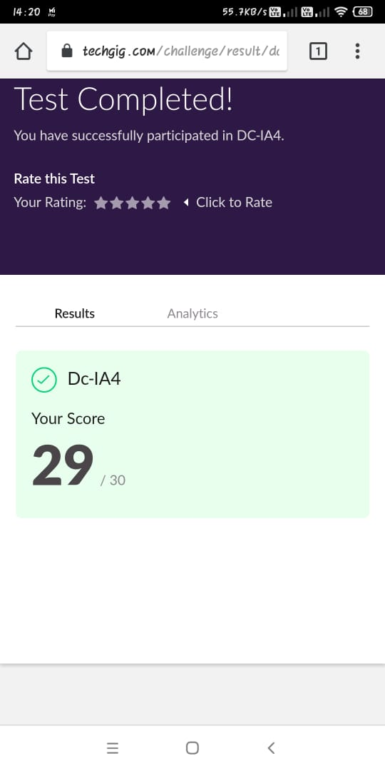

**Online Course Details:**

1. Name of course: **Introduction to R**

Certificate provider: greatlearning

The total course was about the basics and overall introduction to the language. I learnt the different data types, data structures, data manipulation and about plots. I also had few quizzes based on what I learnt as I was advancing through the course.

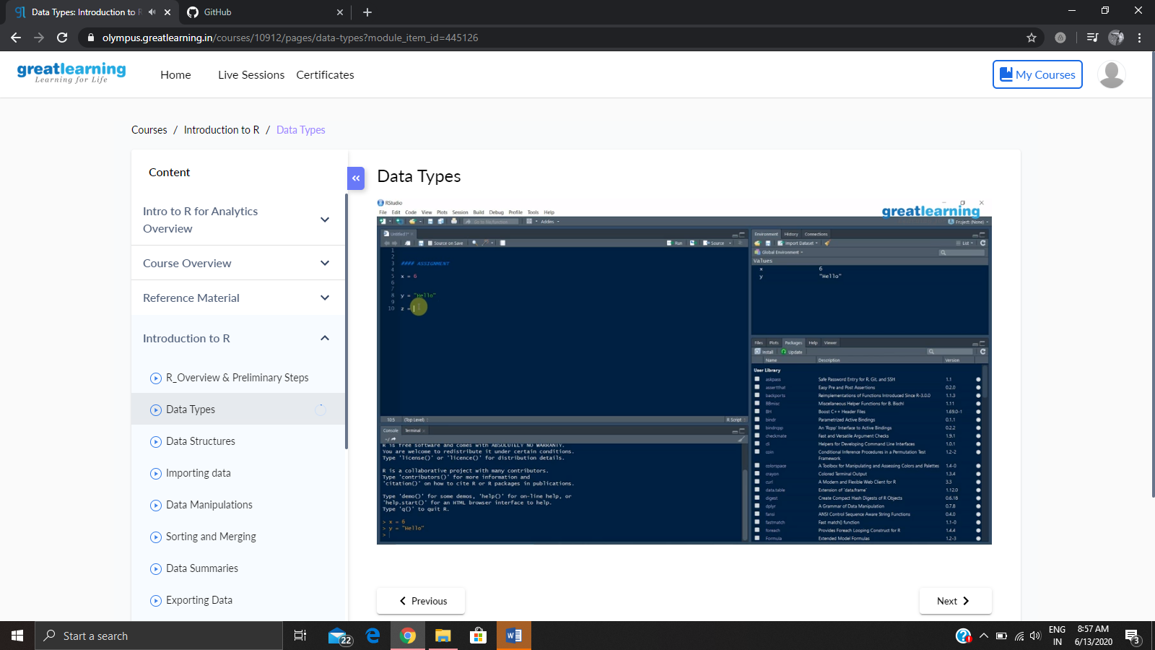

**Online coding:**

Problem 1: (using Python) Program to print prime numbers in an interval

